IT301 Assignment 1

NAME: SUYASH CHINTAWAR
COURSE: PARALLEL COMPUTING
TOPIC: LAB 1

Q1. Find the number of CPUs in system
A) i) lscpu – Hence, no. of CPUs in the system is 8.
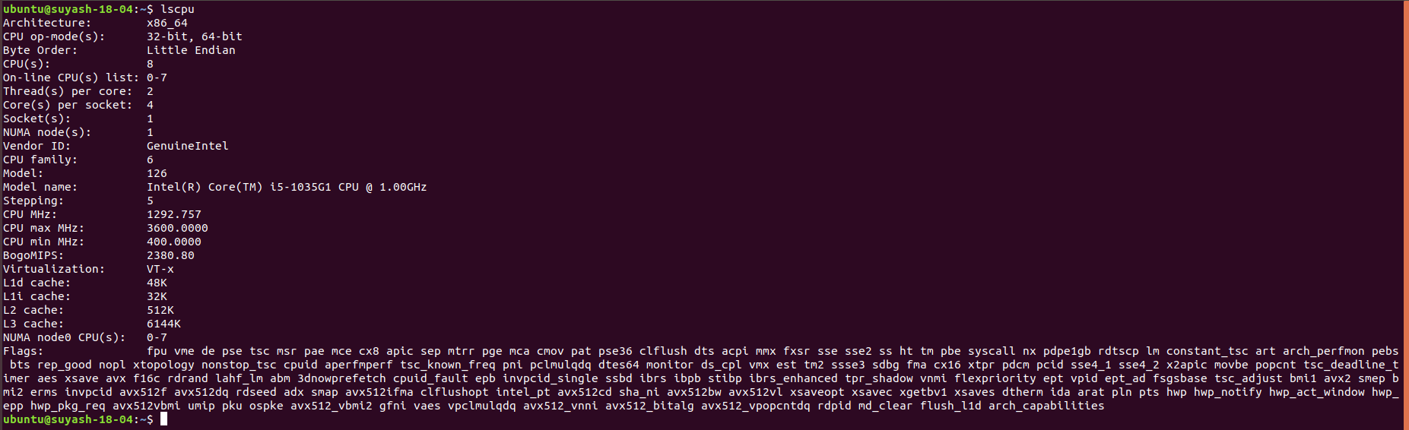
ii) lscpu | egrep 'Model name|Socket|Thread|NUMA|CPU\(s\)'
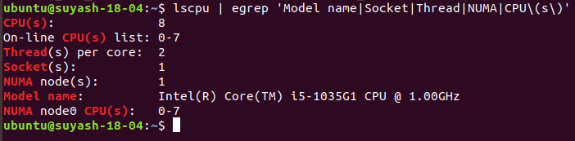
iii) lscpu -p
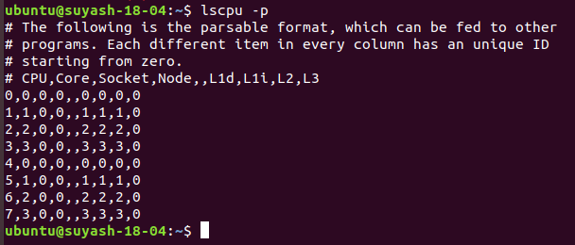

B) top command
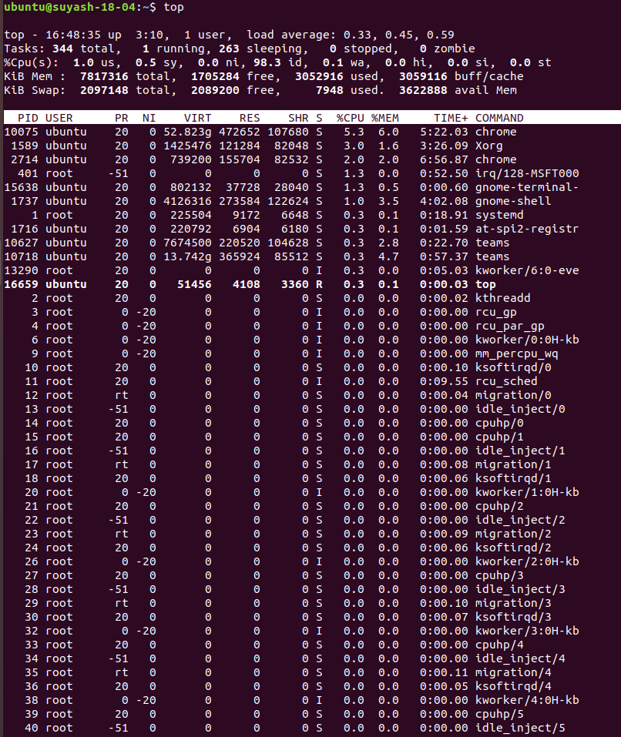

C) i) nproc –all
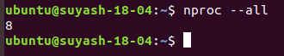

ii) echo "Threads/core: $(nproc –all)"
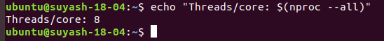

Q2. Write a C/C++ simple parallel program to display the thread_id and total number of threads.
Ans:

Method 1: Using OMP_NUM_THREADS
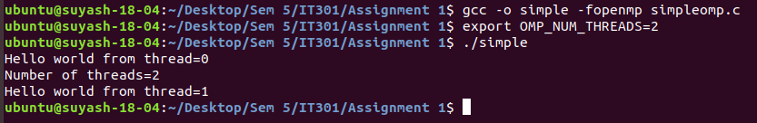

Method 2: Using omp_set_num_threads(x),
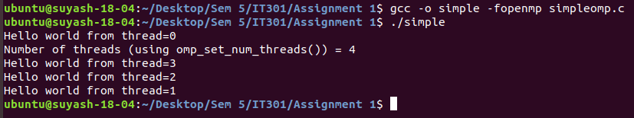

Program for omp_set_num_threads(x),
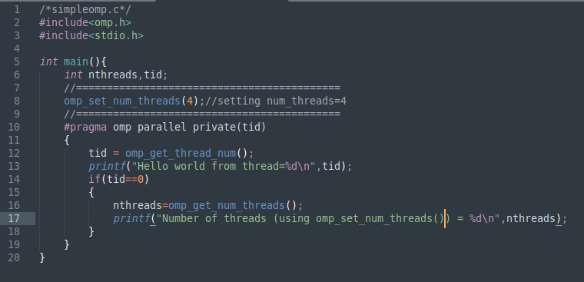
Method 3: using num_threads(),
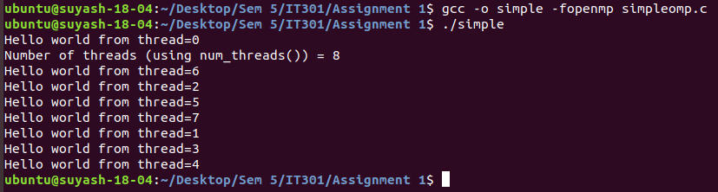
Program for num_threads(),
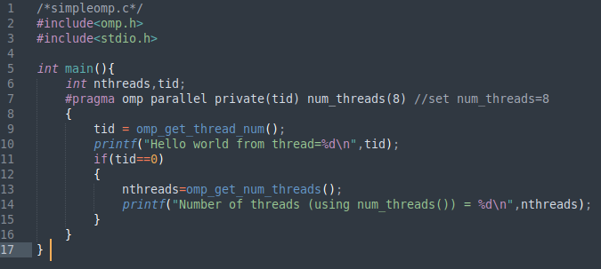

The use of if clause to determine parallel execution is similar to Q3 below.

Q3. Check the output of following program and Note down the output in your observation book. (ifparallel.c)
Ans.
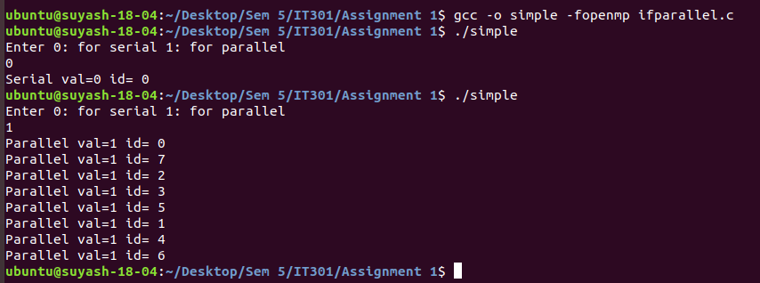
When 0 is entered, serial execution of program occurs and parallel execution if 1 is entered.

Q4. Observe and record the output of following program. Change the num_threads and observe the result. (num_threads.c)
Ans.
When num_threads=4,
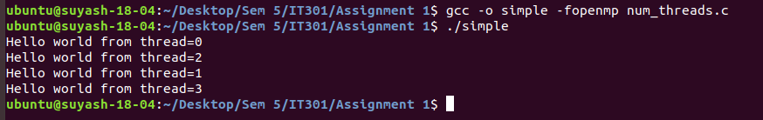

When num_threads=16,
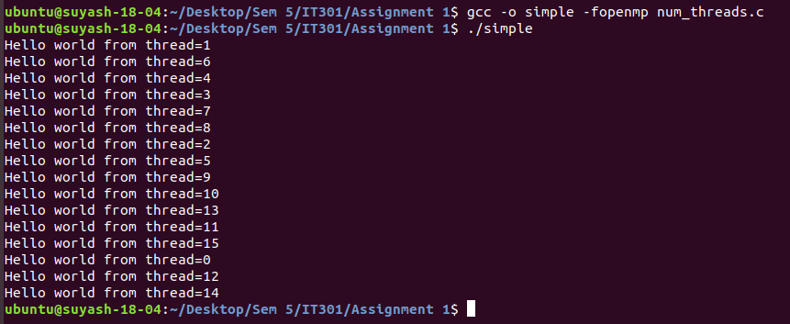
When num_threads=2,
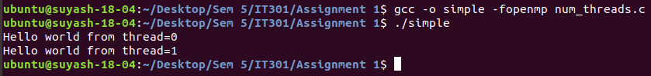
num_threads specify the number of threads to be used for program execution. The part of the program specified under parallem execution gets executed by all the threads and hence we get “Hello World” message from all threads. The order in which threads execute may differ as shown in above output.

THANK YOU

